Fruits are available at some positions on an infinite x-axis. You are given a 2D integer array fruits where fruits[i] = [positioni, amounti] depicts amounti fruits at the position positioni. fruits is already **sorted** by positioni in **ascending order**, and each positioni is **unique**.

You are also given an integer startPos and an integer k. Initially, you are at the position startPos. From any position, you can either walk to the **left or right**. It takes **one step** to move **one unit** on the x-axis, and you can walk **at most** k steps in total. For every position you reach, you harvest all the fruits at that position, and the fruits will disappear from that position.

Return *the* ***maximum total number*** *of fruits you can harvest*.

**Example 1:**

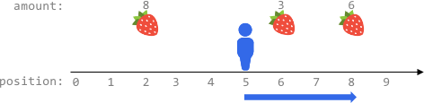

Input: fruits = [[2,8],[6,3],[8,6]], startPos = 5, k = 4  
Output: 9  
Explanation:   
The optimal way is to:  
- Move right to position 6 and harvest 3 fruits  
- Move right to position 8 and harvest 6 fruits  
You moved 3 steps and harvested 3 + 6 = 9 fruits in total.

**Example 2:**

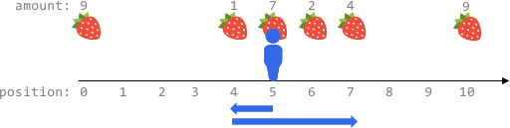

Input: fruits = [[0,9],[4,1],[5,7],[6,2],[7,4],[10,9]], startPos = 5, k = 4  
Output: 14  
Explanation:   
You can move at most k = 4 steps, so you cannot reach position 0 nor 10.  
The optimal way is to:  
- Harvest the 7 fruits at the starting position 5  
- Move left to position 4 and harvest 1 fruit  
- Move right to position 6 and harvest 2 fruits  
- Move right to position 7 and harvest 4 fruits  
You moved 1 + 3 = 4 steps and harvested 7 + 1 + 2 + 4 = 14 fruits in total.

**Example 3:**

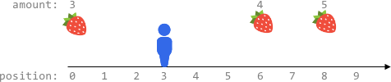

Input: fruits = [[0,3],[6,4],[8,5]], startPos = 3, k = 2  
Output: 0  
Explanation:  
You can move at most k = 2 steps and cannot reach any position with fruits.

**Constraints:**

* 1 <= fruits.length <= 105
* fruits[i].length == 2
* 0 <= startPos, positioni <= 2 * 105
* positioni-1 < positioni for any i > 0 (**0-indexed**)
* 1 <= amounti <= 104
* 0 <= k <= 2 * 105